18 July 2021

Title: IAMCR’s CPT co-organized the 1st CNM books week with CCA

Tags: cultural publics; events; India; China; Singapore; Japan

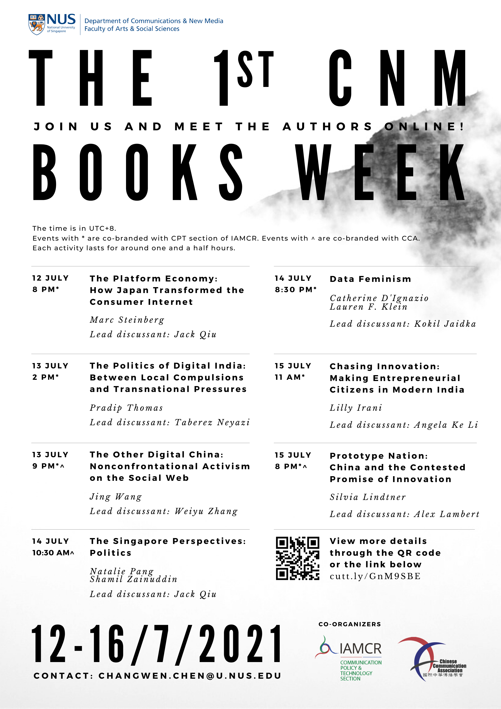

With the help of Dr. Jack Linchuan Qiu, the CPT section of IAMCR co-organized, along with Chinese Communication Association, the Inaugural CNM Books Week at the National U of Singapore in mid-July 2021. The full event series covered 7 books, of which CCA co-branded 3 events on: The Other Digital China (Jing Wang, 2019); Prototype Nation (Silvia Lindtner, 2020); and The Singapore Perspectives: Politics (Natalie Pang and Shamil Zainuddin, 2021). All 7 talks’ e-posters can be accessed here: [https://www.dropbox.com/s/gnk8lqni6c8x2t5/Posters.pdf?dl=0](https://l.facebook.com/l.php?u=https%3A%2F%2Fwww.dropbox.com%2Fs%2Fgnk8lqni6c8x2t5%2FPosters.pdf%3Fdl%3D0%26fbclid%3DIwAR0ghwZCPyPo1vcvJnl9zRB63-hb9ZIqcwgPgRiTQqn7idN53xxvl_h86Fs&h=AT0Ig2L9lFYm-HVXkcTAPZjaAjsTjlT9yIUz4KDzEefcWrrkN_Li5SK6T5ZqQwJhP4Ukegr-CivKkHrqj2Mb10Hgku6_8kRSpT4xi-ZWg7qdN7Sr2UjRJXPLWkbvQl_tOA&__tn__=-UK-y-R&c[0]=AT0GQSh6tn6VG4o_6h-IYy3DPgF6Rcm6HSKomDY7g2yQVBxtik8QyRgE6h9lhG9D7hlSpB4Ehoe49Nm_Ovi1upl-OS3mLFL2IIhFQdz-M1unLt6HX1-Tr9qoeR8enw546PTovICTQqLcWVsZCQqWfw0lCAaJUmleNCpPjukhUMyfvBrTqIqKzgbXrN0rwDyTpfXMusBZ)

27 June 2021

Title: Presentation on “Traffic media in China”

Tags: cultural publics; presentations; China

Dr. Weiyu Zhang delivered a presentation on “Traffic media: How algorithmic imaginations and practices change content production,” during the 18th Chinese Internet Research Conference co-hosted by RMIT, Deakin Univ., QUT, USC Anneberg, and NUS. [[video](https://nusu-my.sharepoint.com/personal/cnmzw_nus_edu_sg/Documents/civictechlab%20website/multimedia%20files/videos/Edited%20videos_Manjiang/3D_Weiyu_Zhang%20(with%20opening).mp4)]

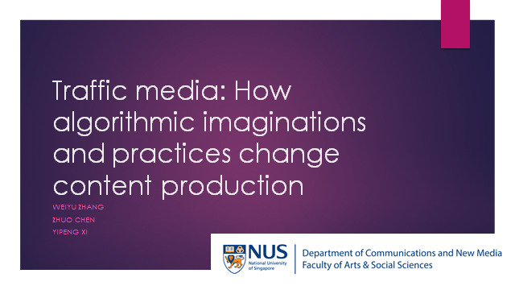

26 June 2021

Title: Presentation on “Multiple Discourses of Gene Editing on Social Media”

Tags: citizen science; presentations; China

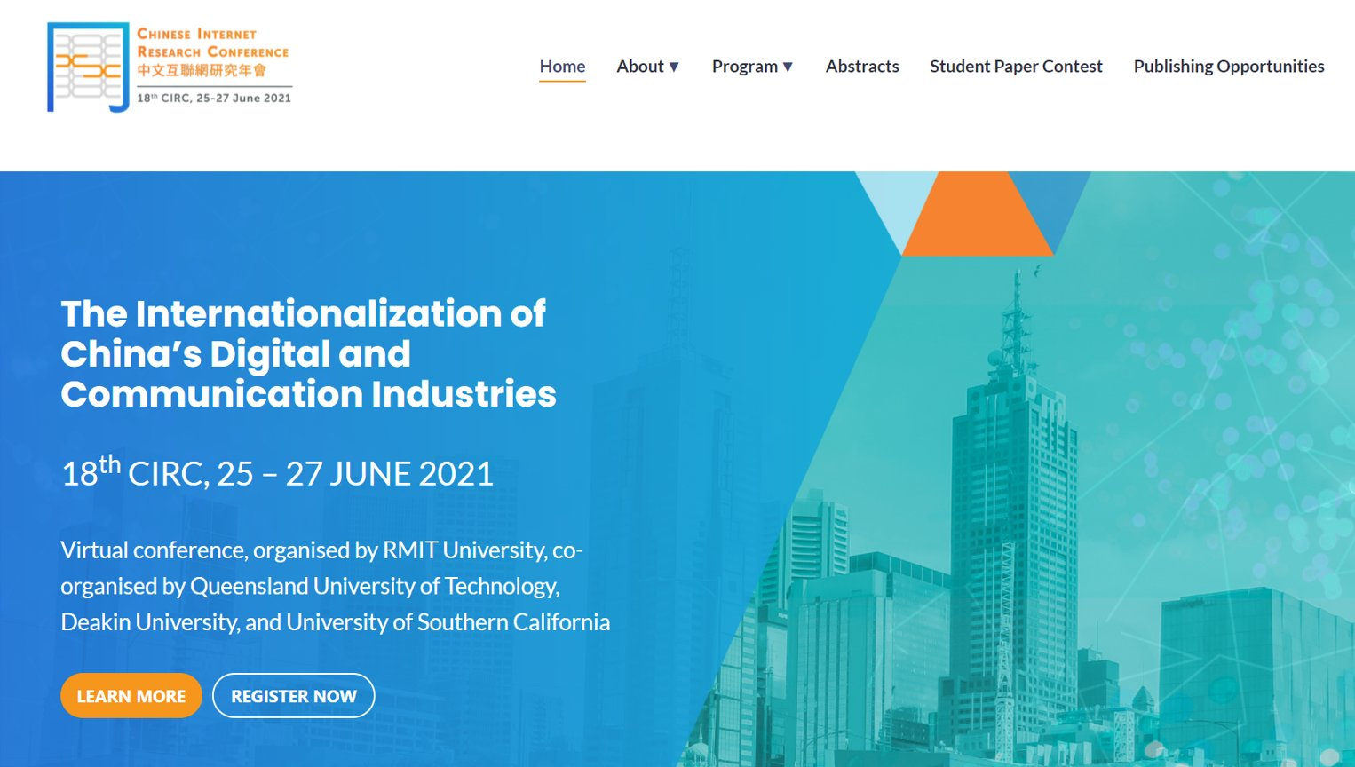

PhD student Xing Zhang made a presentation on “Multiple Discourses of Gene Editing on Social Media: A Case Study of Chinese Gene-Edited Human Babies,” during the 18th Chinese Internet Research Conference co-hosted by RMIT, Deakin Univ., QUT, USC Anneberg, and NUS. [[video](https://nusu-my.sharepoint.com/personal/cnmzw_nus_edu_sg/Documents/Forms/All.aspx?RootFolder=%2Fpersonal%2Fcnmzw%5Fnus%5Fedu%5Fsg%2FDocuments%2Fcivictechlab%20website%2Fmultimedia%20files%2Fvideos%2FEdited%20videos%5FManjiang&FolderCTID=0x0120004D4DD339DF5DCE409DDB1C69B7CBCC22&View=%7BD33405AE%2D76E8%2D4810%2DA0B6%2DF83670F58BBC%7D)]

9 June 2021

Title: Op-ed on “Online deliberation is civic tech”

Tags: civic tech; online deliberation; op-ed; Singapore; poland; brazil



In this op-ed, Dr. Weiyu Zhang argues that “Deliberation needs to be both a means and an end to designing civic technologies. As a means, civic technologists can learn about how citizens understand a piece of technology through deliberation; as an end, only technological design that has involved citizens in a deliberative process can have their social legitimacy. Deliberation should be central in not only discussing but also designing critical technologies such as gene editing and artificial intelligence.”

12 May 2021

Title: Presentation on “The history of Civic Tech in Singapore”

Tags: Civic Tech; Presentations; Singapore

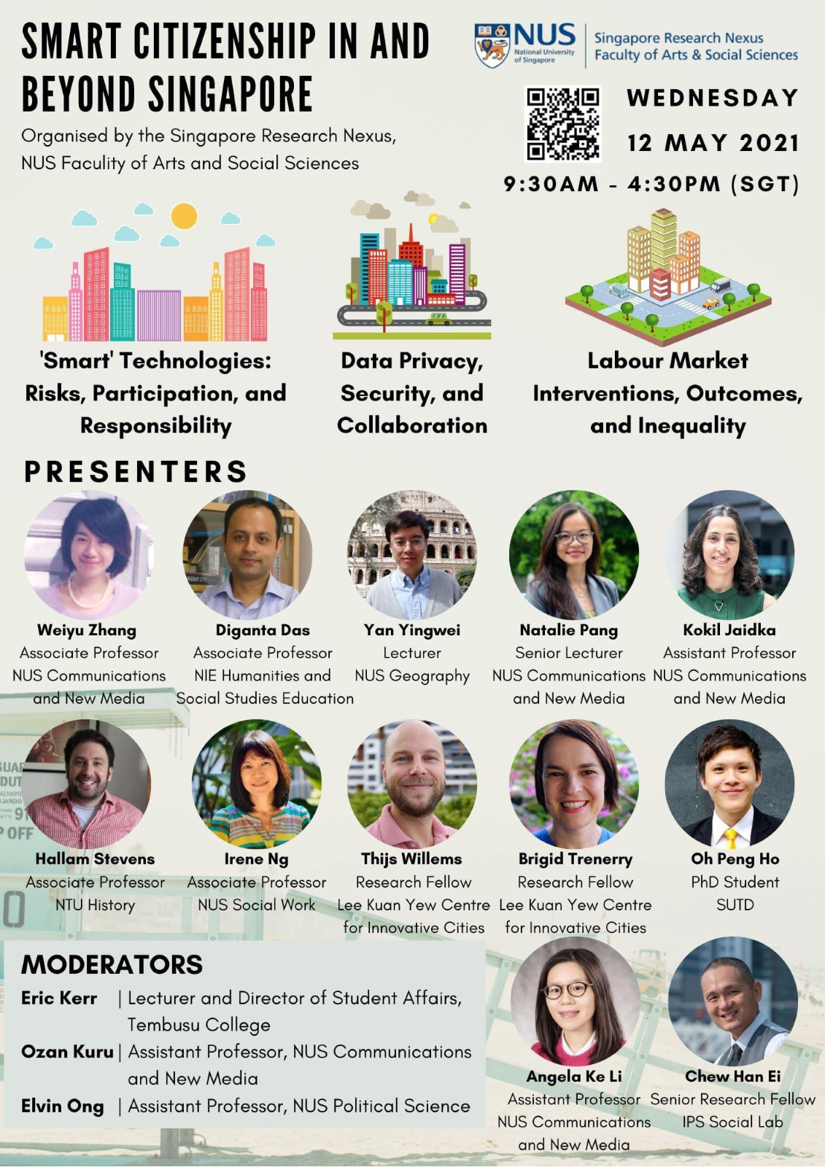

Dr. Weiyu Zhang accepted the invitation from FASS, NUS’s Singapore Research Nexus and made a presentation on “The history of Civic Tech in Singapore.” The virtual event happened on May 12th, 2021 and attracted audiences from academia, government agencies, and the public. [[video](https://nusu-my.sharepoint.com/personal/cnmzw_nus_edu_sg/Documents/civictechlab%20website/multimedia%20files/videos/Edited%20videos_Manjiang/Weiyu%20Zhang%20_%20The%20history%20of%20Civic%20Tech%20in%20Singapore-%20An%20Actor-Network%20Analysis(with%20opening).mp4)]

28 October 2020

Title: IPS forum on Internet and Media Use in Singapore’s General Election 2020

Tags: Cultural publics; civic tech; presentations; singapore

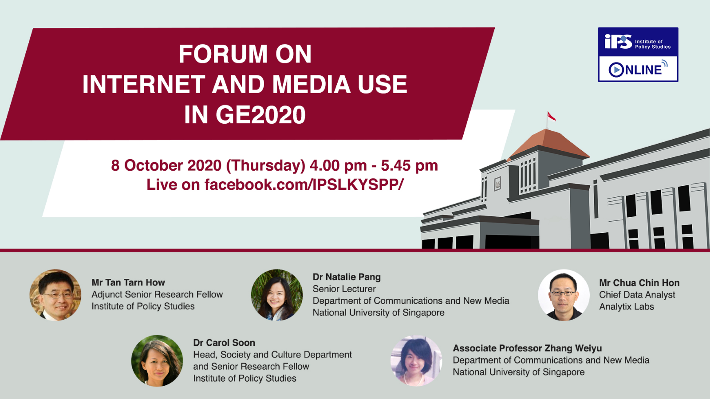

[A forum on **Internet and Media Use in Singapore’s General Election 2020**](https://lkyspp.nus.edu.sg/ips/news/details/ips-online-forum-on-internet-and-media-use-in-general-election-2020) **was held online on** October 8th, 2020 **and open to the public. The research team was led by Dr. Carol Soon from Institute of Policy Studies, NUS. The study was reported and covered in local media:** [TodayOnline ,](https://www.todayonline.com/singapore/ips-post-ge2020-forum-older-voters-catch-digital-use-parties-missed-crucial-online-signals) [Channel News Asia,](https://www.channelnewsasia.com/news/singapore/ge2020-swing-voters-pap-opposition-party-ips-survey-13230088) [Mothership,](https://mothership.sg/2020/10/swing-voters-ge2020/) [Zaobao WeChat.](https://mp.weixin.qq.com/s/DSOOUADKhytd5c6ZfHTwHQ)

15 October 2020

Title: Presentation on “CivicTech For And By Citizens”

Tags: Civic tech; presentations

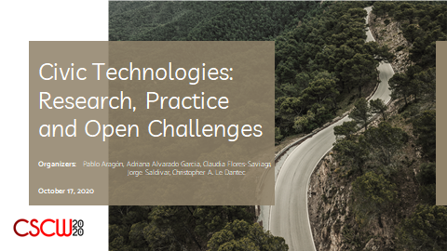

In this position paper, a group of Singapore-based civic tech researchers argues that “While we are progressing well towards the goal of ‘for the citizens,’ ‘by the citizens’ remains largely absent.”

5 February 2020

Title: Workshop on “Civic learning in the social media era”

Tags: youth engagement; civic tech; workshop; Singapore

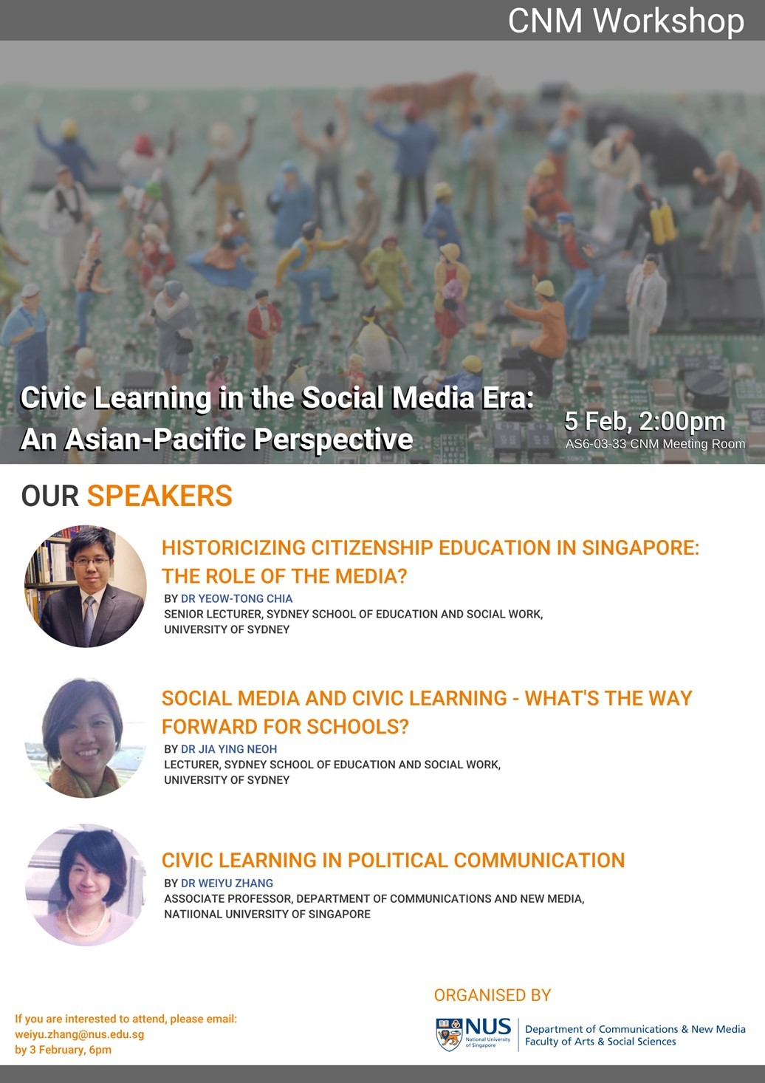

Scholars from Univ of Sydney and National Univ of Singapore co-presented a workshop on “Civic learning in the social media era” on 5 February, 2020.

24 September 2019

Title: A series of 9 book talks on "Fandom Publics in the Making"

Tags: Cultural publics; presentations; China

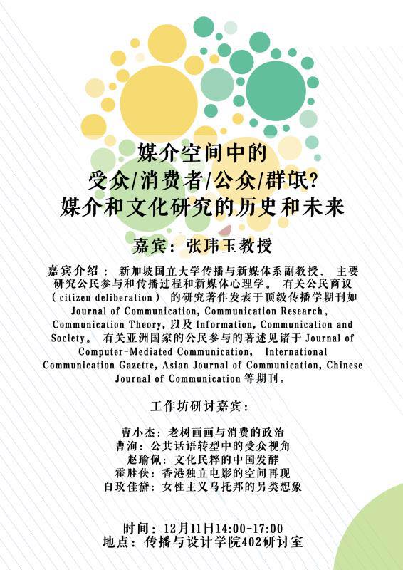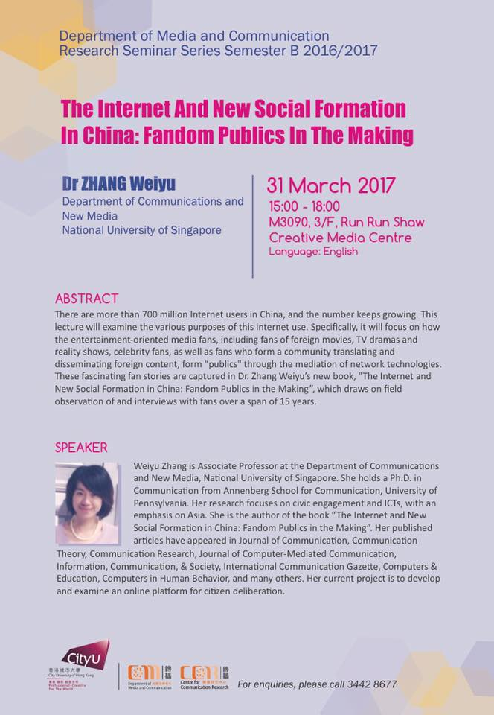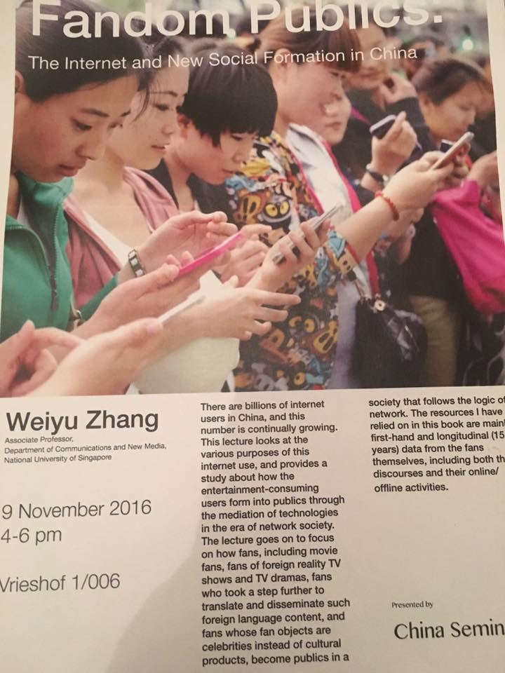

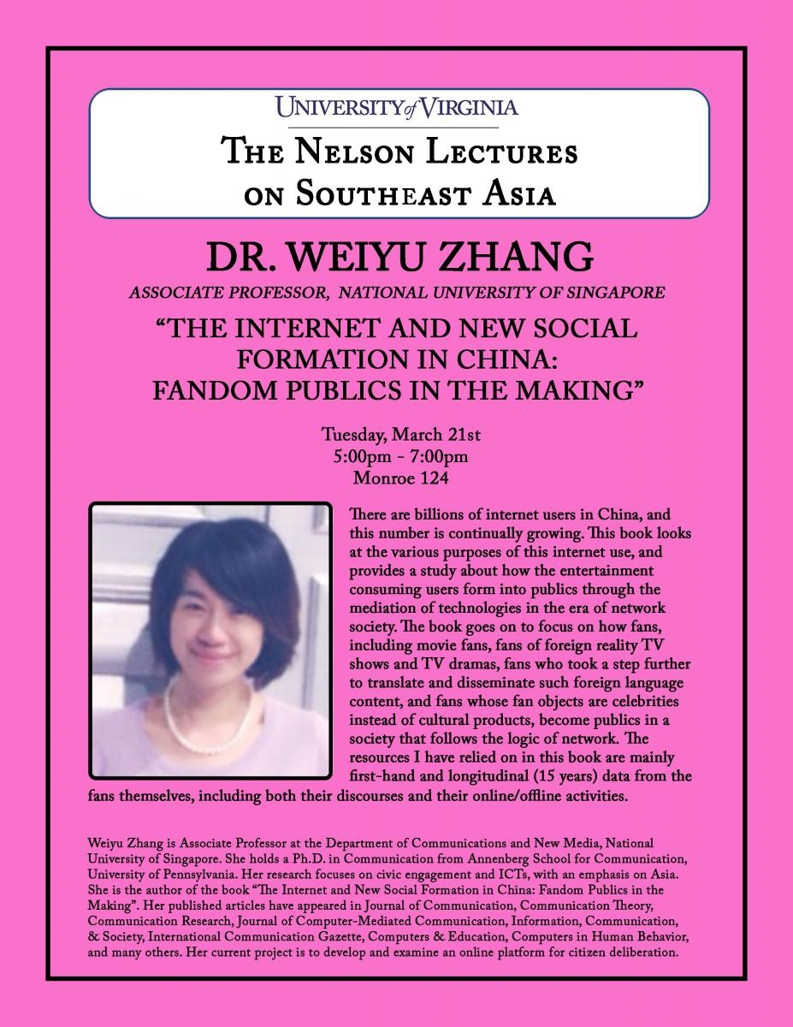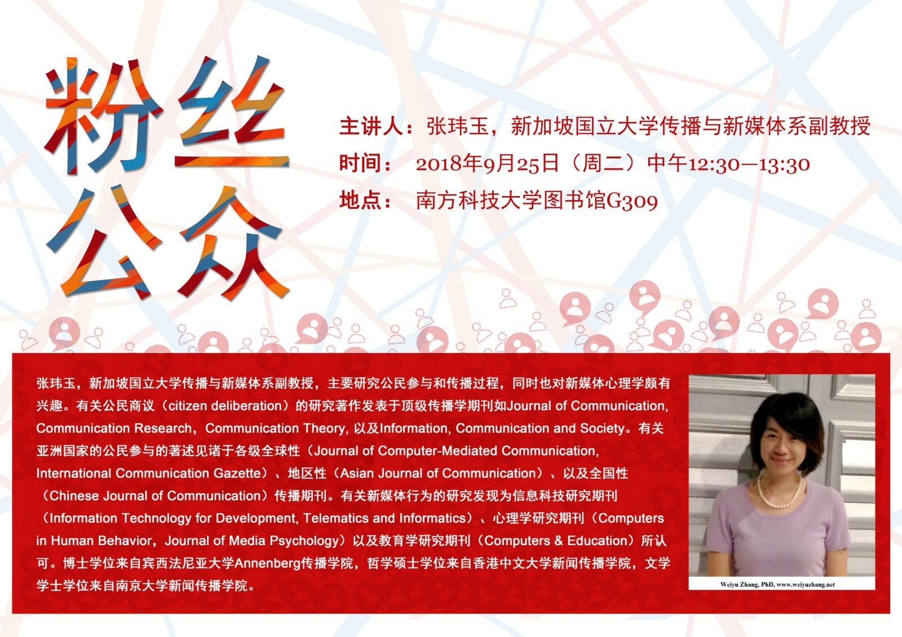

**A series of 9 book talks on "Fandom Publics in the Making" were delivered in either English or Chinese at various universities. [**[**slides**](https://nusu-my.sharepoint.com/personal/cnmzw_nus_edu_sg/Documents/civictechlab%20website/cultural%20publics/fandom%20publics%20in%20the%20making.ppt?d=wff3b9fbe0cda4b148a1dd9d61fcfeef6)**] 【**[**演讲课件**](https://nusu-my.sharepoint.com/personal/cnmzw_nus_edu_sg/Documents/civictechlab%20website/cultural%20publics/%E6%BC%94%E8%AE%B2%E8%AF%BE%E4%BB%B6.ppt?d=w3be71faad4404ab6b7f37bc5c34ea6dd)**】**

* City University of Hong Kong, March 31st, 2017
* University of Virginia, March 21st, 2017
* Chinese University of Hong Kong, January 18th, 2017
* Leiden University, November 9th, 2016
* Royal Holloway University, September 20th, 2016
* 2019年9月24日 -- 广西艺术学院
* 2019年7月2日 -- 南京师范大学
* 2018年9月25日 -- 南方科技大学
* 2017年4月1日 -- 中山大学

28 June, 2019

Title: 17th Chinese Internet Research Conference (CIRC) held in Singapore!

Tags: Cultural publics; conferences; China; Singapore

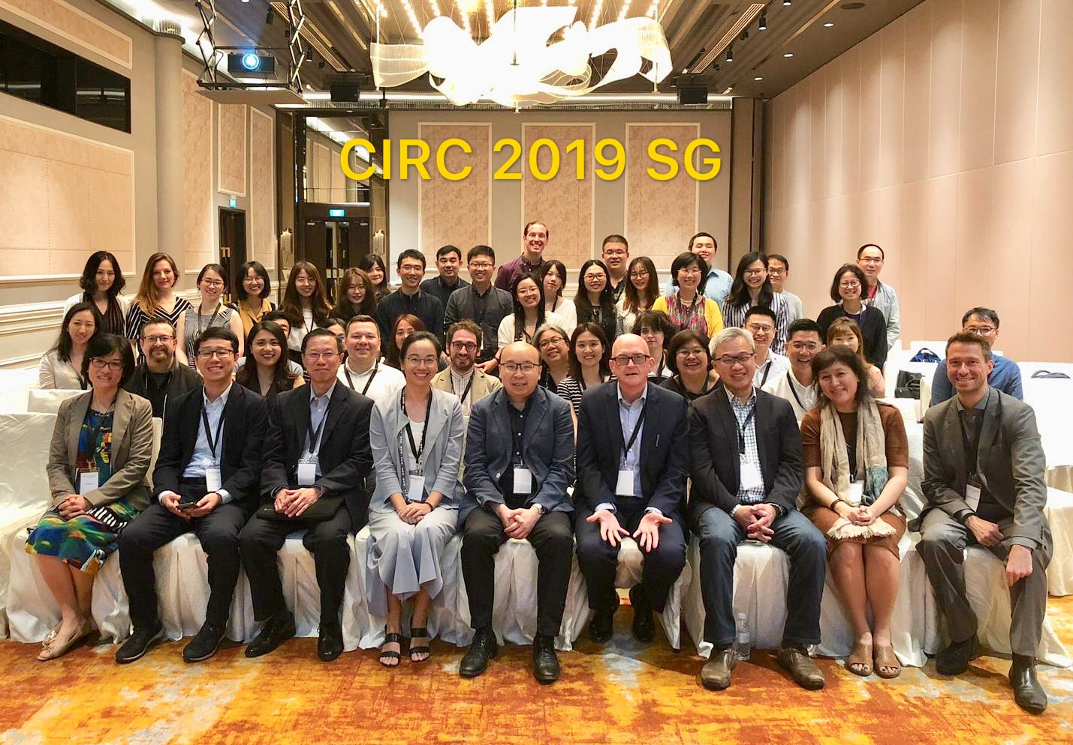

The 17th Chinese Internet Research Conference (CIRC) on “Digital Cultures: Chinese Internet and Beyond” was held on June 28, 2019 in Orchard Hotel Singapore. The conference was co-hosted by NUS and Murdoch University. More than 60 participants registered for this day long conference, including both academics and government officials. Researchers coming from all over the world (China, Australia, United Stated, Netherlands, Singapore, etc) made 29 presentations during the day. Two special issues, one in [*Global Media and China*](https://journals.sagepub.com/doi/full/10.1177/2059436420939322) (GMC) and one in [*Chinese Journal of Communication*](https://doi.org/10.1080/17544750.2020.1848405) (CJoC), have been published based on the conference submissions.

24 June 2017

Title: Deliberation and Decision Making (DDM2017) held in Singapore!

Tags: online deliberation; civic tech; conferences; singapore

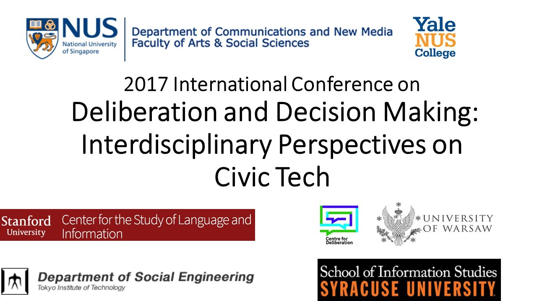

**Deliberation and Decision Making (DDM2017): An Interdisciplinary Conference on Civic Tech was held in June, 2017 in Singapore. The conference led to the publication of a symposium “**[**Online Deliberation and #CivicTech**](https://delibdemjournal.org/article/id/988/)**” featured in the Journal of Deliberative Democracy.**

2 June 2016

Title: Interview with Annenberg School for Communication, Univ of Pennsylvania

Tags: Cultural publics; interviews; China

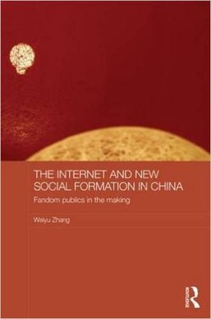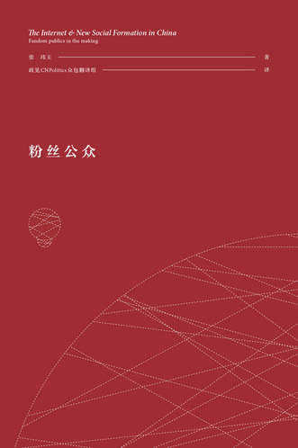

Dr. Weiyu Zhang had an [interview](https://www.asc.upenn.edu/news-events/news/annenberg-student-and-alumna-collaborate-crowdsource-book-translation) with Penn Annenberg on the crowdsourced translation of the book "Fandom Publics in the Making" in June 2016. The translation project was a collaboration with the then Annenberg PhD student, and now Dr. [Kecheng Fang](http://www.com.cuhk.edu.hk/en-GB/people/teaching-staff/fang-kecheng).

31 May 2015

Title: SIG on “online deliberation processes and technologies” held in CHI 2015

Tags: online deliberation; civic tech; workshop; south korea

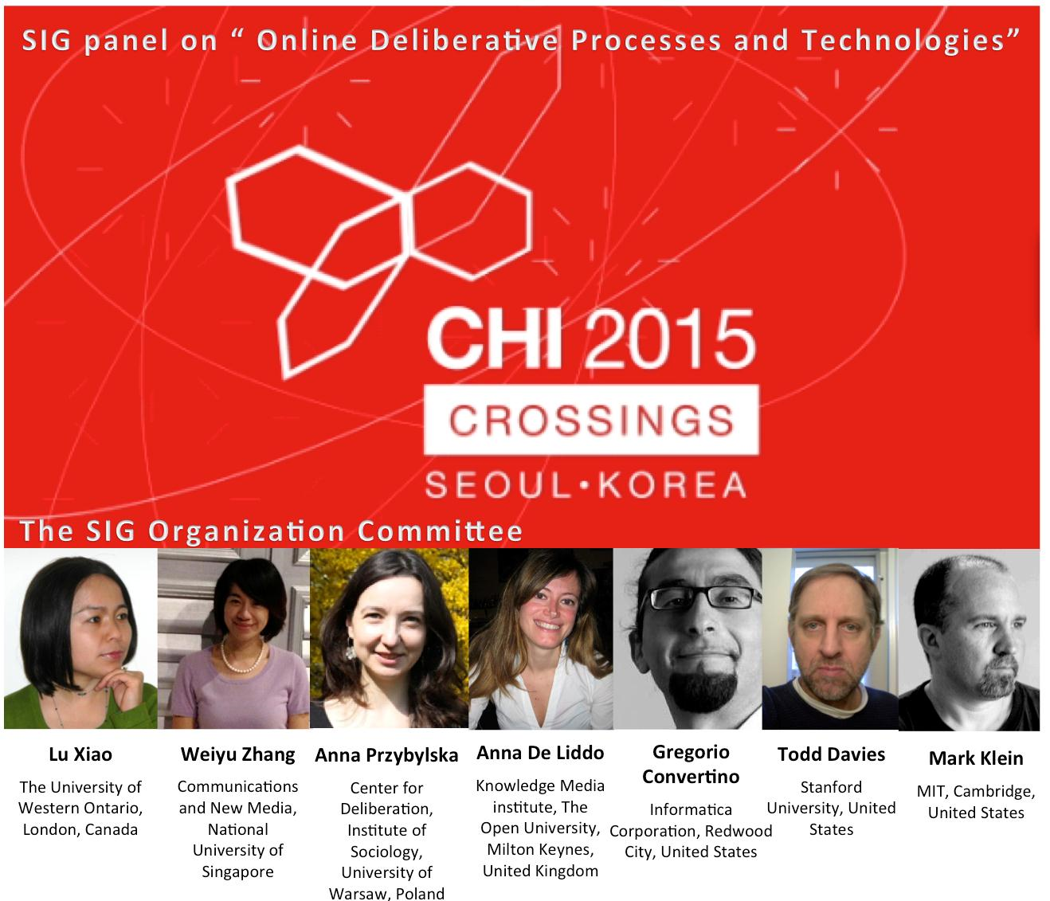

Scholars from Canada, UK, US, Poland and Singapore co-organized a workshop on “design for online deliberation processes and technologies” during the 2015 CHI in Seoul, South Korea. This was the first time when the social scientists and computer scientists gathered in one room to tackle the challenge of online deliberation.

30 June 2014

Title: Keynote speech on **“celebrity activism on Weibo”**

**Tags: cultural publics; presentations; china**

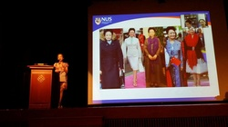

**Dr. Weiyu Zhang gave a keynote speech on “celebrity activism on Weibo” at the 2014** Chinese Internet Research Conference (CIRC) **,** held at Hong Kong Polytech University. [[slides](https://nusu-my.sharepoint.com/personal/cnmzw_nus_edu_sg/Documents/civictechlab%20website/cultural%20publics/celebrity%20activism%20on%20weibo_2.ppt?d=wb7c70e7d45ad456abf30041734fe5968)]

21 July 2012

Title: Panel on “Youth, ICTs, And Civil Engagement in Asia: A Comparative Approach”

Tags: youth engagement; presentations; south africa; Asia



The team of researchers collectively presented at a panel during the 2012 International Association of Media and Communication Research Conference, held in Durban, South Africa.

18 August 2011

Title: Keynote lecture for the 22nd International Youth Forum

Tags: youth engagement; presentations; south korea



Dr. Weiyu Zhang was invited to deliver a keynote lecture at the 22nd International Youth Forum, Ministry of Gender Equality and Family and National Council of Youth Organizations in South Korea. The talk is titled “*Change, Youth, Failure, Excellence.”* [[slides](https://nusu-my.sharepoint.com/personal/cnmzw_nus_edu_sg/Documents/civictechlab%20website/youth%20engagement/Change%2C%20Youth%2C%20Failure%2C%20Excellence.ppt?d=w357b922ba8d24c198fbf40bb543aa809)] [[transcript](https://nusu-my.sharepoint.com/personal/cnmzw_nus_edu_sg/Documents/civictechlab%20website/youth%20engagement/A%20talk%20prepared%20for%20the%2022nd%20International%20Youth%20Forum.doc?d=w7a02169826d244b781a751ca8fada929)]

8 July 2010

Title: Presentation on “Youth Engagement and ICTs in Asia”

Tags: youth engagement; presentations; Asia

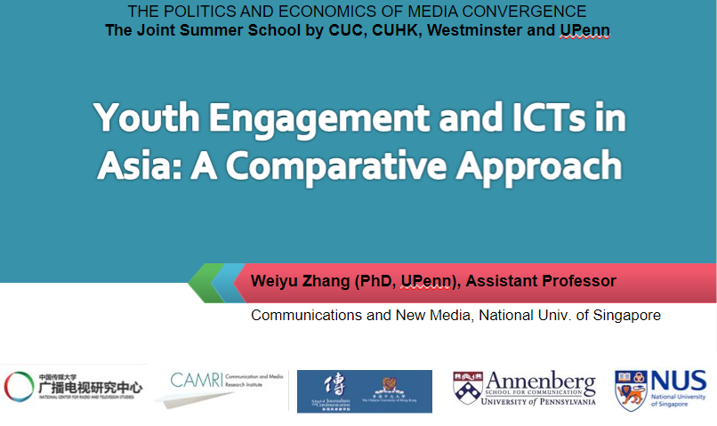

Dr. Weiyu Zhang was invited to speak at the Joint Summer School by Chinese University of Communication, Chinese University of Hong Kong, University of Westminster and University of Pennsylvania, Chinese University of Communication. The talk is titled “Youth Engagement and ICTs in Asia: A Comparative Approach.” [[slides](https://nusu-my.sharepoint.com/personal/cnmzw_nus_edu_sg/Documents/civictechlab%20website/youth%20engagement/CUC%20presentation.pptx?d=w69a02116c063402c92d238392373d1d4)]

24 June 2010

Title: Panel on “Youth, ICTs and Political Engagement in Asia”

Tags: youth engagement; presentations; Asia



The team of researchers collectively presented at a panel during the 19th AMIC Annual Conference “Technology and Culture: Communication Connectors and Dividers”, held in Singapore. [[slides](https://nusu-my.sharepoint.com/personal/cnmzw_nus_edu_sg/Documents/civictechlab%20website/youth%20engagement/intro_amic.pptx?d=w273876f4d20f40228f8f99c9743da6ba)]

31 March 2010

Title: Participation in an International Workshop on ICTs and Development

Tags: youth engagement; civic tech; workshop; India

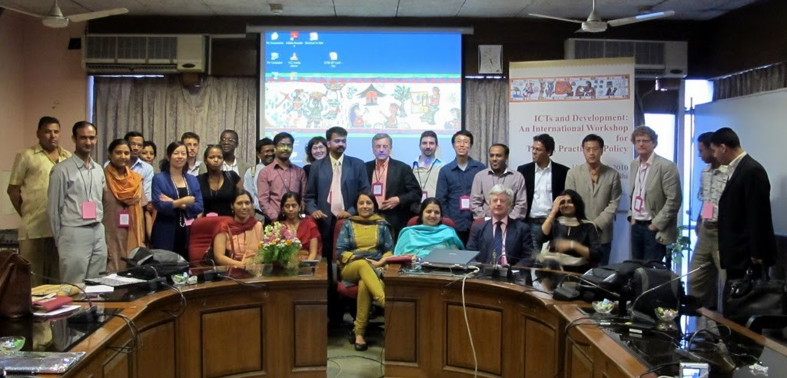

Dr. Weiyu Zhang was invited to participate in an International Workshop on ICTs and Development, held in IIT Dehli, India.

30 September 2009

Title: Talk on “Pushing democracy: Prospects for media and technology”

Tags: civic tech; presentations; Philippines



Dr. Weiyu Zhang delivered an invited talk on e-democracy as part of a conference “Peace, Human Rights, Good Governance: East Asian Democracies at the Crossroads”, hosted by The Philippine Center for Investigative Journalism. The presentation is titled “Pushing democracy: Prospects for media and technology.” [[slides](https://nusu-my.sharepoint.com/personal/cnmzw_nus_edu_sg/Documents/civictechlab%20website/civic%20tech/Pushing%20Democracy.ppt?d=wc758c1a0c9d848f98f874b10c4c1c850)]